Google Machine Learning Course (With tensor flow APIS)

Intro to Machine Learning
Peter Norvig.

Framing
We will be covering supervised machine learning.

Supervised machine learning involves combining input to produce useful predictions on never seen before data.

We have to provide the model with labels. (spam or not spam). These labels are what we are predicting, the output variable of a formula.

Features are the way we represent data. (email address, subject, email contains a particular phrase, words in the email). This is an input variable. A simple ML project might use a single feature, whereas a more complicated one might use many.

An example is one piece of data (an email), can be labeled or unlabeled. It is a vector. We use labeled examples to train the model.
Labeled examples: {features, label}: (x, y)
Unlabeled Example: {features, ?}: (x, ?)

The model is the thing doing the prediction, we create through processing data. This defines the relationship between features and labels. Training means we are creating or learning the model, showing it more examples to learn relationships between features and labels. Inference is when we apply the trained model to unlabeled examples, using it to make predictions about the labels. There are two sorts of models: Regression, which predicts continuous values (probability, value of house, etc) and Classification, which predicts discrete values (spam or not spam, is this cat or not?)

Descending into ML
We use Linear Regression to fit a line to a set of data.
y = wx + b – w is weights in machine learning, giving us our slope, b is our bias, and remember that this may just be one dimension of many.

Loss is how good our line is at predicting any example from the data set. One useful loss function is L2 Loss, aka the squared error. Take the squared difference between observation and prediction. We want to minimize the loss for our entire data set against our model.

You could have a model with three features, and it might look something like: y’ = b + w1*x1 + w2*x2 + w3*x3

Training is the process of determining good values for all the weights and bias from labeled examples. The Supervised ML algorithm attempts to find a model that minimizes loss. Loss is a number that indicates how bad our model’s prediction is on any particular example from the data set, the goal of training the model is to find the model with the least overall loss.

The Mean Square Error is the average squared loss per example over all of the data, it is a very popular loss function. MSE it is not the only loss function, and sometimes it is not the best.

Reducing Loss
We use as the gradient as a guide in parameter space to reduce loss; the gradient gives us a direction to move in order to reduce loss. We take the derivative of the loss function (the gradient) after we have computed a result, then we modify the weights in the direction of the negative gradient. How large of a step do we take? This is determined by the learning rate, a hyper parameter that we configure. You want to find a learning rate large enough such that gradient descent converges efficiently, but not so large that it never converges.

Weight Initialization: Different problems have different shapes; convex problems (bowl shaped) are straight forward – as long as we start somewhere in the bowl, we can descend down into the minimum. However if there are multiple (local) minimums, then initialization does matter (we want to start close to the global minimum). The mathematical literature behind machine learning suggests that we want to compute the gradient over the entire data set, but empirical evidence has shown that its good enough to go through one example at a time (this is called the Stochastic Gradient Descent), which allows us to reduce the computational burden significantly. In practice though, the gradient descent is computed in batches of somewhere between 10 and 1000, called Mini-Batch Gradient Descent.

Reducing loss through an iterative approach: We start with a wild guess of weights, compute what the loss is, try another weight, compute the loss again, and note if we are getting better or worse. The real trick of this is to find the best possible weights as efficiently as possible.
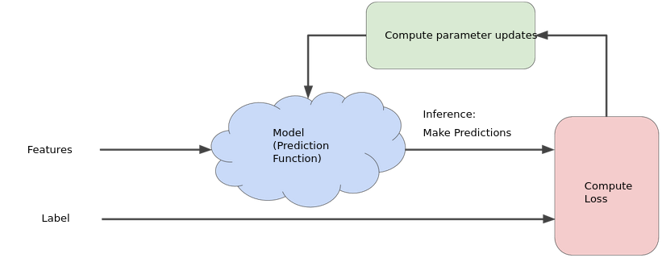
The course suggests that there are other, non iterative, strategies to reducing loss, but that iterative strategies are popular because of large data sets.

The model takes in one or more features and produces one prediction as the output.

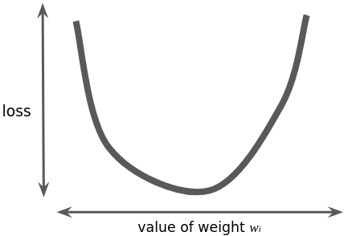
If we had the time and computation to calculate the loss values for each possible weights to a single feature linear regression problem, the graph would look like the image here, a upward opening parabola.

Convex problems like the graph have only a single minimum. A more time efficient and popular method for finding the minimum of the loss function is gradient descent (though the course suggests its not the only method).
After you’ve determined the loss for your randomly selected weight value, you then compute the gradient of the loss function at that point, telling you which direction to move.

Learning Rate: The gradient is multiplied by a scalar known as the learning rate (aka the step size) to determine the next point. Hyperparameters are knobs that programmers tweak in machine learning algorithms. The ideal learning rate comes from the inverse of the second derivative, this is simple for one dimension problems, but for 2 or more dimensions, we use the Hessian.

Stochastic Gradient Descent: A large data set with randomly sampled examples contains redundant data, which can be sometimes useful to smooth out noisy gradients, but enormous batches generally do not carry much more predictive value than large batches, and are thus not worth the added computational effort. The Stochastic Method takes a single randomly chose example from the data set per iteration, which produces a functional, but noisy, method of gradient descent. In practice, Mini-batch stochastic gradient descent is a compromise between full batch and SGD that uses around 10-1000 examples, reducing the noise from SGD but producing more accurate results from full-batch.

Question: How do we perform gradient descent without knowing the actual formula? We know the input formula (weights and features and bias), and we know the loss value. I guess the gradient loss

Intro to Tensor Flow
Keras is a deep learning API that we will be using in the course.
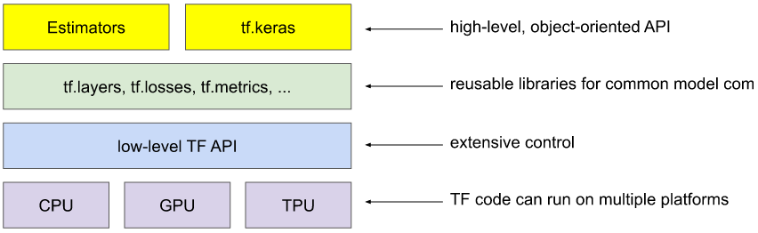

A quick reminder of vector multiplication.

There is scalar multiplication, aka the dot product. Remember that this tells you how similar two vectors are.
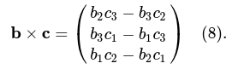
As well as vector multiplication, multiplication of two vectors that produces another vector, called the cross product. The cross product produces a vector perpendicular to the two input vectors

import pandas as pd
import tensorflow as tf
from matplotlib import pyplot as plt

Although scaling a label is usually not essential, scaling features in a multi-feature model usually is essential.

When exploring a data set, be wary of using columns with anomalies as features – they can often wreak havoc on a model, however if the labels themselves are anomalous, features like this can be powerful; pre-processing to such features can sometimes be preformed in order to make columns into useful features.

We can create synthetic features – a feature not present among input features, but can be created from one or more of them. We could for example, take the ratio of two features, or bucket features into groups and make those buckets features, it could be the multiplied product of two different features, etc.

We can create a correlation matrix that tells us which raw values relate to other raw values – the higher the correlation value the more predictive power. Pandas dataframes have a built in method to build a correlation matrix. training_df.corr()

Generalization
Machine learning is not just fitting training data – we are interested in generalization: creating a model that will work well for novel data.

Its possible to over fit our models to the training data. To avoid doing this, we can strive to create a model that is as simple as possible, and validate our model against data not used in the training set.

Input data: We have a process that generates data, and we don’t know the details of that process, all we know is the labeled data that comes out of that process.

Ideally we want to train on a data sample, and know that this training will work well on future novel data. According to Ockham’s Razor, we should be more inclined to desire a model that is as simple as it can be; having too complicated of a model will lead to over fitting.

We can split out input data into training set and test set. If we do as good on our test set as we do on our testing set, we have a good idea that things might generalize well.

Basic Assumptions to make the above test/train set hold:
- We are drawing examples independently and identically (I.i.d) from the distribution.
  - Examples are not influencing one another
- The distribution is stationary; it doesn’t change over time
- We are always pulling from the same distribution

These form the basis of a lot of supervised learning, but in practice, sometimes these do not all hold true – for example a distribution might change over time in the real world.

Training and Test Sets
The bigger the training set, the better our model. The bigger our test set, the more confidence we have in the trained model. Never ever ever train on test data. The test set needs to be an accurate subset of the entire data set – make sure you aren’t selecting data that biases in one data or another (training on summer data but then testing on winter data, etc) – randomize your data set first.

Validation
When tuning hyper parameters, you want to periodically re-generate your test set, so you know you aren’t tuning your hyper parameters to a single distribution of your actual data.

In order to avoid overfitting our hyperparameters to the test set, we can create a third partition in our data called the validation set. We could train on the test data, do a validation on the validation data (to tune hyper parameters), and then once you think you’ve reached a good value, confirm the results on the test data.

The loss curves of the data set and the validating set differ significantly is a common problem – make sure you always randomize your data set before doing the training and the validation.

shuffled_train_df = train_df.reindex(np.random.permutation(train_df.index))

Representation
You have to choose features from a data set in order to train.

Machine learning engineers spend about 75% of their time on extracting features – called feature engineering.

We can often convert strings in the data set into meaningful features using one-hot encoding; a vector that contains yes or no for all of the expected values, similar to an enum, where each enum value is 1 bit of a word. When doing this mapping, the input set is called the vocabulary of possible values. Since not all strings will be represented, we can determine the most common / expected ones, and all other inputs can go into a catch all “other” category known as OOV (out of vocabulary) bucket. We use these binary vectors, where each value is a categorical feature and represented by a bit, because the weights are applied to these features, so a 0, 1, 2, 3 values for categorical representation might not work well - 0 * anything is always 0. If multiple values from the binary vector can be active or hot, then it is called multi-hot encoding. In sparse representations, only non-zero values from the vector are written – zeros are inferred to improve data storage.

Good Qualities of Features: What makes a feature a good feature: it should be nonzero at least sometimes. Features should have clear and obvious meaning – age in units of years instead of seconds since Unix Epoch. Magic values are bad, that is, values that have special meaning, use a different Boolean feature instead (have a feature that says “feature X is valid” true or false); for the feature itself, store the average if it is continuous, and a special value if it is discrete. Feature values should not change over time. Features should not have crazy outliers. For discrete values, make sure that each value you’ve identified is represented several times in the data – if there are only one or two examples, best to just lump it into an “other” category.

Cleaning Data and Formatting Features:
Bucketing a continuous feature into discrete bins is often useful – perhaps raw latitude is not a good feature, but maybe certain ranges of latitude values provide meaningful insights. These buckets will be represented as bits in a binary vector, similar to the one hot encoding. We could also bin by quantile, that is, bin by count of entries instead of some static range.
There are several methods to filter out outliers. You can take the log of the values, but there still might be a tail. We can also cap out values higher than a certain threshold, putting all of them in the same bucket. So values between 0 and 100 might be continuous, but then everything > 100 is 101.
In a feature set that consists of multiple features, it is beneficial to scale features into a common range because: 1) it helps the gradient converge more quickly, 2) It keeps the weights from getting too large or too small (floating point error or even NaN), 3) The weights are learned better – one big feature value won’t outscale the others. One common scaling technique is to take the Z Score of each value, how many standard deviations away from mean each example is: scaledvalue = (value – mean) / stddev
Features are not always trustworthy and clean, sometimes you have to do some scrubbing, taking care of things like 1) omitted values, 2) duplicate examples, 3) bad labels, and 4) bad feature values. Generally you just remove bad values from the data set.

Good Habits: Very important to know your data. Don’t treat data as a black box.
- Visualize your data through various plots.
- Data debugging – look for duplicate values, outliers. Dashboards are important.
- We want to monitor features over time to ensure

Feature Crosses (Synthetic Features)
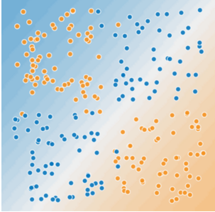
Synthetic features can allow us to learn a non-linearity in a linear model through what is called the feature cross product, or just crosses. Linear learners are important to us because they scale very easily to massive scale data sets – for a long time they were the only only method that would scale to million+ size datasets (now there are deep neural nets though).

You can cross a feature with another feature, you can cross many features together, you can even benefit from crossing a feature with itself (to make it always positive for example).

With crossing one-hot feature values, we obtain logical conjunctions. For example if we had a feature country, and another feature language, the cross would be this language in this country, etc It is very very common for models to cross one-hot feature vectors; the size of this cross will be N * M, where N and M are the sizes of the two vectors, again it will only be one hot, so only one of the N*M bits will be set. Linear learners scale well to massive data. Using feature crosses on massive data sets is one efficient strategy for learning highly complex models. Neural networks provide another strategy.

Regularization for Simplicity:
You want features that fit your data. If you have a linear set of input data, it does not make sense to have crazy non-linear feature crosses as your input.

We want regularization, which is, not trusting your input examples too much. Even though we’re training on the training data, what we care about is the test / validation data, because we want to generalize to new examples. Regularization helps us avoid overfitting to our training data.

We can have different inputs to our training strategy, beyond just loss reduction, we could also have a factor that penalizes the model for being complex. So we would minimize [Loss(Data | Model) + complexity(Model)], this is called structural risk minimization.

There are multiple ways to define complexity.
One is method is to consider the size of weights, and to prefer smaller ones. We can encode this idea through L₂ regularization (a.k.a. ridge) – penalize the sum of the squared values of the weights: Loss(Data|Model) + (lamda) * (w₁² + w₂² + …). In this equation the lambda is a simple coefficient that balances how much we care about simplicity vs loss reduction. If your lambda term is too high, meaning you try to keep the model as simple as possible, you run the risk of underfitting – the contrary is true for a smaller lambda as well.
Another method of defining complexity is to look at the total number of features that have non-zero weights.

Logistic Regression
A logistic regression generates a probability between 0 and 1. This is a new loss function. Can be used for calibrated probability estimates, meaning we can multiple the probability times other values to get expected values of the output.

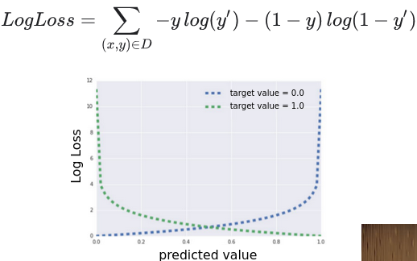
We take our linear model and stick it into a sigmoid function, a function that gives us a bounded values between 0 and 1. At training time we use log loss instead of the squared loss function we were using previously. He says that the log loss function looks very similar to Shannon's entropy measure. In the loss function, y is either 0 or 1, since it comes from the set of labeled examples D, where y’ is the output of our sigmoid, so analyzing the function, this means that only one of the two logs will actually be non-zero, where each log term will compute how far that y’ is from the expected value (either 0 or 1).

There are asymptotes in both the log loss and the sigmoid, which means we need regularization, in order to avoid our model trying to reach the asymptote. Logistic regression models use either L₂Regularization or Early Stopping to avoid asymptotic approach – if the model attempts to miniamize a feature, it can never get to zero, so it will continually grow and grow towards the asymptote.

We like linear logistic regression because its really fast, extremley efficient for calculating probabilities. Good for low latency, and we can even capture non-linearities by using feature cross products.

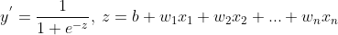
It is common to map a probability output to a binary value: “given that this is the probability that this event will happen, do we think it will happen tonight?”

Sigmoid:
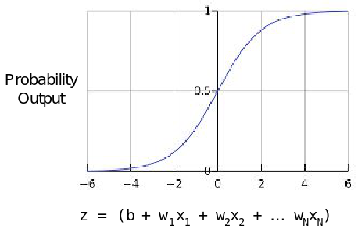

Classification
We can use logistic regression as a basis for classification; use the probability input to determine the classification value through a threshold value. This threshold value is problem dependent, so we can’t always go with something like 0.5.
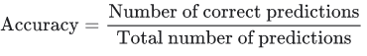
We need new metrics to evaluate the ability of this model, one thing we use is accuracy, what percentage of inputs did we get correct?

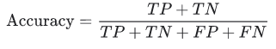
We want to use the grid that analyzes True Positives, False Positives, False Negatives, True Negatives. In these terms, Accuracy is defined as the following equation.

Accuracy does have some flaws though, when we have data set with class imbalance: if you have something that only happens 1/1000 times, then choosing always false, you would be correct 99.9% of the time. When we have these sorts of data sets, we need to use some additional metrics to evaluate models.
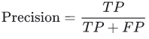
We can also use these values to calculate Precision: how often was the model correct (True positives / All positives)?
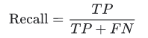
Recall is also interesting, how many of the true positives did we correctly identify? (True positives / Count of actual true positives).

Precision and Recall are generally in Tug of War with each other, and you must examine both of them in order to correctly evaluate a model. Increasing the threshold will generally increase precision (the ratio of true positives on the right of the threshold will increase) while the recall will generally decrease (as more positives will become false negatives on the right side of the curve).
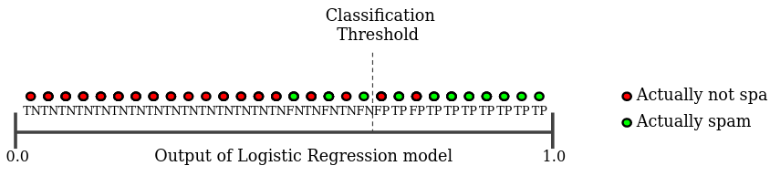
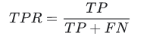
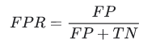
Both Precision and Recall are well defined when we have a threshold value chosen, we might want to analyze our model across various different classification thresholds, we can do this using a Receiver Operating Characteristic (ROC) Curve, a curve of TP vs FP rate.

The area under the ROC curve (AUC) is the probability that the model ranks a random positive example more highly than a random negative example; it gives us the aggregate measure of performance for all possible classification thresholds. AUC is desirable for two reasons
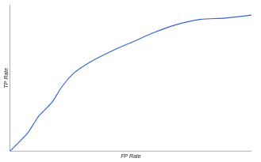Figure 1: ROC Curve
- AUC is scale-invariant. It measures how well predictions are ranked, rather than their absolute values.
- AUC is classification-threshold-invariant. It measures the quality of the model's predictions irrespective of what classification threshold is chosen.
In a sense, the AUC gives us an idea of how many of the positive values are to the right of the output, and how many of the negative values are to the left of the output, it gives us a general idea of how good the model is irregardless of the actual threshold value; if we had a really high AUC area, that would mean that most of the positive values are on the right, most of the negative values are on the left, and we can choose a threshold value that will result in awesome model accuracy, precision and recall.
AUC is not always the most useful metric; sometimes we don’t want something scale invariant, because maybe the absolute values matter; and sometimes we don’t want something that is classification threshold invariant, because perhaps recall matters more than precision.

We also have prediction bias: the sum of all of the things we predict compared to the sum of all of the things we observe, we want them to be the same, the difference is the bias. Ideally, the average values of the predictions of logistic regression, should match the average value of the observation. Prediction bias is a useful ‘canary’, telling us we have some non-zero bias, meaning there is a bug somewhere in the model, however a low prediction bias does not tell us our model is good, rather it can just be used to tell us if there is a problem.

Regularization: Sparsity
A sparce matrix, sparse vector, or sparse array is simply a matrix or vector that has most of its values as zero.

Crosses can have some caveats, particularly for sparse features; say we have a vector with a million possible values, crossed with another vector with million values, we could have a new vector with million*million values, which would consume huge amounts of memory and slow training. With sparse vectors, most combinations can often be super rare, causing over fitting. To handle this, we want to zero out some of the coefficients, in order to reduce the size.
Causing a feature to go to zero effectively removes it from the model.

L₀ Sum the Norm of the weights. Regularization where we try to zero out coefficients, but this is NP-hard, non-convex, very computationally difficult. This is the ideal though, because we would be counting the non-zero terms.
L₀: (||w₁|| + ||w₂|| + …)

L₁ Serves as a approximation of L_{0.} Regularization Is what we use instead, because it is convex. It penalizes the sum of the abs(weights).
L₁: (|w₁| + |w₂| + …)

Both of these improve on L₂ regularization, where the weights are driven towards zero, but arent actualy driven to zero.
L₂: (w₁² + w₂² + …)

The derivatives of these regularization functions are different – L₂ essentially results in 2*weight, so proportional to the value of the weight, meaning the weight is reduced by some iteration every iteration, but is never actually reduced to zero (Zeno); L₁ results in a constant value, however thanks to the absolute values, there is a discontinuity at 0, which causes subtraction results that cross zero to become zero.

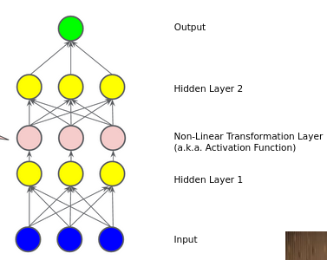
With L₁ Regularization, if you increase the regularization rate (lambda) too much, you might cause useful features to decrease to 0. If you’re not careful, L₁ can cause useful features to go to 0 weight for other reasons too.

Neural Networks
The promise of deep neural nets is to learn non-linearities automatically, without having to construct a complicated feature cross, especially for complex data such as video and audio.

We might think we could handle non-linear data by adding more and more layers, but if the input to each of the next layers is a linear combination of the previous outputs, then it will all still just be a linear predictor – a linear combination of a linear output is linear. So we have to add in a non-linearity in between some of our hidden nodes in there. The layers in between are called the hidden layers.

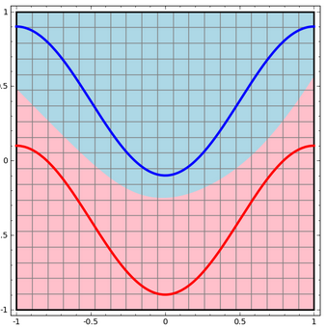
A common non-linearity is called Relu, which takes a linear function and chops it off at zero. This is an activation function. Relu: F(x) = max(0, x). We could also use sigmoid or tanx, but Relu turns out to work just as well and is very simple.

Stacking non-linearities between layers allows us to model very complicated relationships. They allow for learning a more complex, higher-level function over the raw inputs.

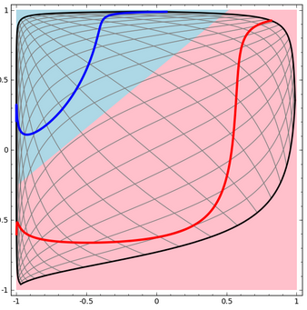
With low-dimensional deep neural networks (few nodes in each layer), we can visualize what each of the nodes are doing and map it into topology. Each layer might do some sort of transformation on the input data such that it can represent it in a way that the data is linearly separable. One example of a transformation is tanh – tanh(Wx +b), where first the linear transformation from the weight matrix (W) is applied, then the translation vector b shifts the result, then tanh is applied to each point; up until the application of tanh, all of the transformations were linear. Topological properties are preserved – layers stretch and squish, but never cur, break or fold; Transformations which do not affect topology are called homeomorphisms.

Each node in each layer is essentially a dimension, so you can add another hidden unit, and allow for a change in perspective that might allow you to separate things, in a higher dimension. For example, no homoemorphism you apply to the annuls to the right can provide a linear separable red and blue with two units in your hidden layer – but if you add a third dimension (a third unit), you can suck the red out into the positive z and the blue into the negative z, as it does in the 3d graph below, and then you can use a plane to separate the data sets.

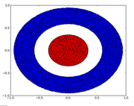
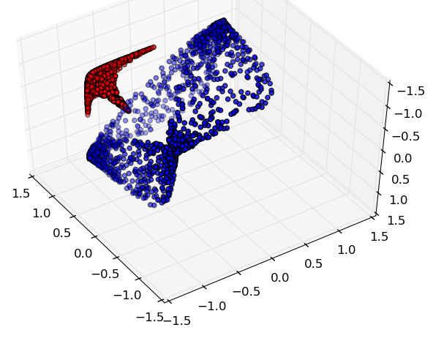
Since we have all these layers, once we try to train them, we are in a non-convex optimization, and thus initialization may matter. We use Backpropagation to train these, which is a model of gradient descent that allows us to perform the gradient descent on the non-convex optimization in a reasonably efficient manner.

If you have too many neurons, and thus are trying to learn the data in a higher dimensional space in which it exists, you will get over fitting – it allows the model to start doing things like drawing circles around particular points.

Although initialization matters, if you get the topology of the network just right, you can get reasonably good results, regardless of the starting conditions.

Common Pitfalls of Neural Networks
- Too many nodes in the graph. Computationally expensive to update weights. Not very interpret-able, we have no idea what all of the nodes are doing. Just because the data might look complicated, that doesn’t mean you need tons of nodes to compute it, feature engineering is more useful.
- No regularization – complex models end up giving us really spiky results that overfit to the training data. We don’t want regularization too high though, or it won’t learn any complexit.

Training Neural Networks
Tensor flow implements back propagation for us, so we don’t have to implement it. It relies on the idea of gradients, so things have to be differentiable; so if we have a hole or some sort of incontinuity in our equation, we can’t take the gradient there. (he says we can handle one or two incontinuities)
Gradients can vanish. If a model gets too deep, signal to noise ratio vanishes.
Gradients can also explode if the learning rate is too large, resulting in NAN.
ReLu layers can die – since ReLu has a lower limit of 0, and everything less than that is 0, then we can kill the outputs of the nodes.
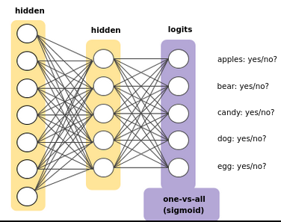
Drop Out is a form of regularization where we will drop out units from the network for a single gradient step.

Multi Class Neural Networks
Here we explore classifying between one of many values.

One vs All Muti Class Classification: We have one logistic regression output node for every model in our class, that is, we essentially end up with one binary classifier for each of the possible outcomes, but have them all together in a single network.

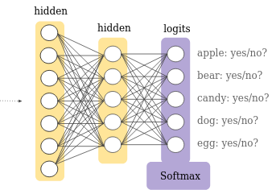
When we are doing Multi-Class, Single-Label Classification (we are choosing one from many), we want the sum of all of our output nodes to equal one. We can achieve this using SoftMax: a generalization of our logistic regression, but general to more than one class.

When we are doing Multi-Class, Multi-Label Classification, then we want independent logistic regression nodes, and the sum of the output does not necessarily sum to 1, so we will not use softmax.

To the right you can see the softmax equation, and a python snippet detailing what it essentially does. Basically you can scale all of the probabilities so that the sum is 1.0

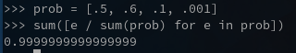
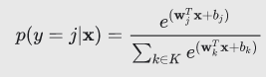
The Candidate Sampling method of SoftMax is self descriptive – you only run the equation on the candidate nodes. So if we are evaluating what kind of animal something is, so we already know it is an animal, we only look at the dog and bear nodes in the example to the right.

There are a few options for SoftMax that we can use.
- Full SoftMax will calculate for all classes.
- Candidate Sampling: We train the output nodes for the class that it belongs to, but only a random sample for the negatives. When we are training a model for the breed of dogs, when we get a picture of a toaster, we don’t need to update all of the individual nodes, we just update a random sample of them.

Embeddings
An embedding is a relatively low dimensional space which you can translate into a high-dimensional vectors. Embeddings translate large sparse vectors into a lower-dimensional space that preserves semantic relationships; rather than having 1 million input nodes, we convert this million dimension space into a much lower dimension space.

Collaborative Filtering: Lets say we want to recommend movies for people. We have 1 million movies, and 500k users, and we know what movies they all liked, so we want to recommend new movies to others – we need a way to determine that some movies are similar to eachother. We can create a bunch of dimensions to rate the movies on (children/adult, blockbuster/arthouse, tragedy/comedy, etc). Movies that end up close together (euclidean distance) in the created space are similar. We are really making the assumption that we can categorize movies by the N dimensions we have chosen. This is called an embedding (which can be of N dimensions), and we can learn embeddings automatically with deep neural networks. In our embedding space, each word can be described by a coordinate. Some times dimensions have actual semantic meaning (like verb, noun, etc), other times they do not, in which case they are called latent dimensions – as it represents a feature that is not explicit in the data, but is inferred from it.

The embedding layer is just a hidden layer, and we have one unit for each dimension we want in the embedding. We need some sort of signal that movies should be near to eachother (movie liked or not liked by users for example). We want a sparse, multi hot input representation, where we only have the choices that are valid fed into the network. We do this to try and minimize the memory needed, and ideally throw out dot products that we have to compute for the back propagation that go to zero.
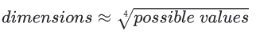
One of the additional hyper parameters of an embedding is, how many dimensions do you want in the embedding layer? The rule of thumb is that the number of dimensions should be the 4th root of the size of the vocabulary.

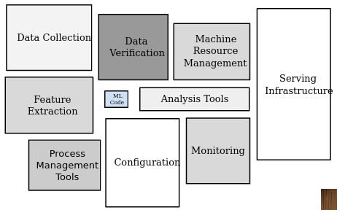
Embeddings can be taken as a tool, where it takes a group of items, and put them into some space. Its a way to group things.

Production ML Systems
ML Models need to be part of a larger ecosystem.

There are a large number of off the shelf components that you can use for your application. There are a few design choices that influence which of these components you use.

Dynamic vs Static Training
Static Model, offline training – train the model once with a big repository of data.
Good time to use is when we have a model where input won’t change much (image recognition is one example).
Pluses: Easy to build and test
Minuses: Still requires monitoring of inputs. The data can easily grown stale

Dynamic Model, Trained Online - continuously updating with new examples
Good time to use this model is when we have changing input data.
Pluses: Adapts to changes. Progressive validation, rather than a batch training and test.
Negatives: Needs monitoring, model rollback and data quarantine capabilities

Static vs Dynamic Inference
Inference is simply making our predictions.
offline inference: Make all possible predictions in a batch. Write the predictions to a table and then feed these into a cache/lookup table.
Upsides
- We can verify the predictions on data before pushing the model
- Don’t need to worry about the cost too much
Drawbacks
- Need to have all of the predictions in hand
- Updating the model takes hours or days possibly
Online inference: Predict on demand, using a server
Upsides
- Can run any new crazy example, can preform predictions on all possible items
Downsides
- Computationally intensive, latency sensitive
- Need more monitoring to make sure things aren’t going haywire – things can change suddenly due to upstream issues

Data Dependencies
In software engineering, we want as few code dependencies as possible. In machine learning, we want as few data dependencies as possible—the input features we use for training and prediction.

Fairness
We have to deal with human bias in all things, because humans store what is typical for objects. For example, if we saw a bunch of regular, ready to eat bananas sitting on the shelf, we would just say they are bananas, not yellow bananas.

Reporting bias is the tendency that people report things in terms of what they find interesting, not what is most frequent.
Selection bias – the example we choose are not a random sampling
Over generalization – conclusion that is made on not enough data
Out group homogeneity bias – assume that groups we don’t interact with every day are more similar to each other than our in group
Confirmation bias – searching for information that confirms existing bias

Facets is a tool which you can use to visualize your data for ML purposes.
https://pair-code.github.io/facets/
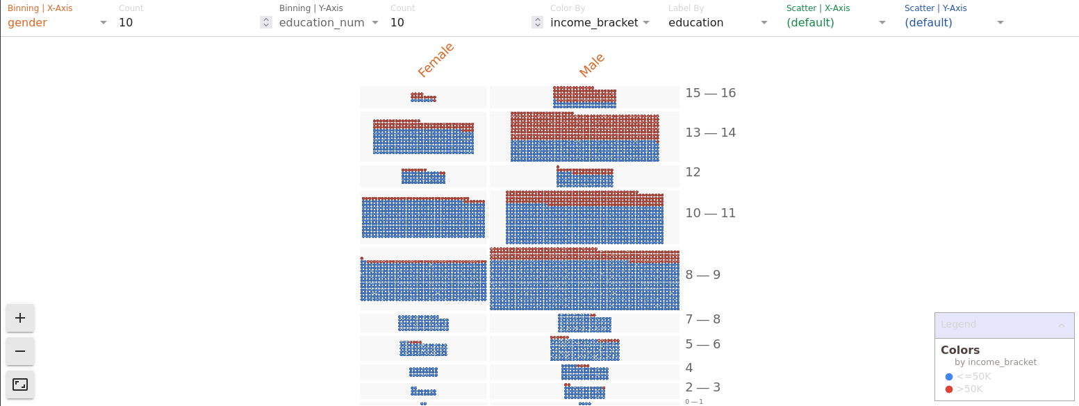

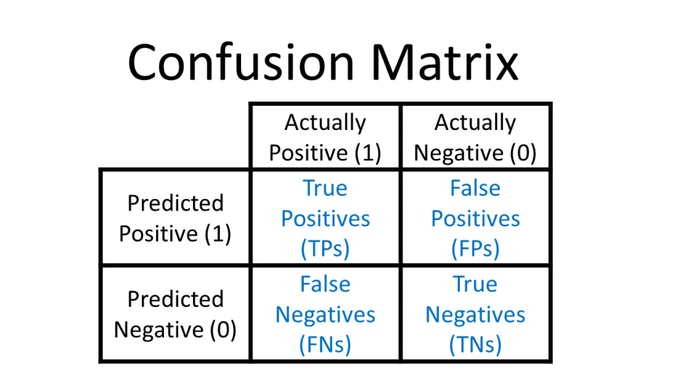
A confusion matrix (aka a error matrix), is a table layout that allows for visualization of the performance of an algorithm.

Questions to ask about your input data
- Is this data reliable? Is it produced the same way every time I need it? Is it always available? Perhaps it comes from some upstream source (and other features come from other upstream sources)
- Does the system which produces this upstream signal ever change? How often would that happen? Adding versioning can be beneficial
- Is this feature really necessary? Do we get enough benefit from this feature to justify the cost of including it?
- Are some of the input signals tied together so that we need additional strategies to tease them apart?
- Are any of my input signals influenced by my models outputs? Feedback loops.

Leakage: Where a little bit of the training labels leak into the features and allow the model to cheat. Such as a model predicting cancer, and the name of the cancer being included as a feature – patients going to hospitals specializing in cancer are more likely to have cancer.

Steps for an Effective ML solution
- Keep the model simple. Start with only a linear regression model to validate the pipeline
- Make sure the pipeline is correct, end to end.
  - Bugs in the data pipeline are hard to track down
- User a simple observable metric for training and evaluation
- Own and model the input features as much as possible
- Treat the model configuration as code. Review. Test. Check in.
- Write down the results of all experiments, including failures.

Running Questions
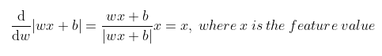
What do these weight functions look like, and how can we take the derivative of them? What are the variables? Are they simply coefficients? If so, what does it mean to take the derivative of the loss function? Is it X (dot) W?, so the derivative of that? Is each function simply W*X+B?, so the derivative is just W?

So for L₁ regularization, the derivative would look like the figure on the right, which is why the result is a constant?

What is a gradient step?

Cheat Sheet
Hyper Parameters
Learning Rate:
Regularization:
Regularization Rate (Lambda)
Batch Size:
Validation Set Size:
Test Set Size.

Terms
Features
Feature Cross

